Name: Varia Neel Jitesh
Enrollment No: 250447003019

Web Application Security – Lab
Objective
To perform and analyze the given web application security experiment in a controlled environment using Damn Vulnerable Web Application (DVWA).

Lab Environment
The experiment is conducted on Damn Vulnerable Web Application (DVWA), which is a deliberately insecure web application designed for security testing and educational purposes. It provides multiple vulnerability levels (Low, Medium, High) to simulate real-world web application security scenarios.

Platform Details
- Operating System: Windows
- Web Application: Damn Vulnerable Web Application
- Server Environment: XAMPP (Apache, MySQL, PHP)
- Access Method: Web Browser (Localhost)

Procedure
- Open a web browser and navigate to the DVWA application:
~ http://localhost/DVWA
- Log in to Damn Vulnerable Web Application using valid credentials.
- Navigate to the DVWA Security tab and set the security level (preferably Low for initial testing).
- Select the required vulnerability module (e.g., SQL Injection, XSS, File Upload) from the DVWA menu.
- Enter appropriate input/payloads in the provided fields to test the vulnerability.
- Analyze the application’s response to observe how the vulnerability is exploited.
- Record the results, including payloads used, outputs obtained, and conclusions from the experiment.

Login using below credentials: -
Username: admin
Password: password

Experiment 1:
SQL injection attack, querying the database type and version on Oracle
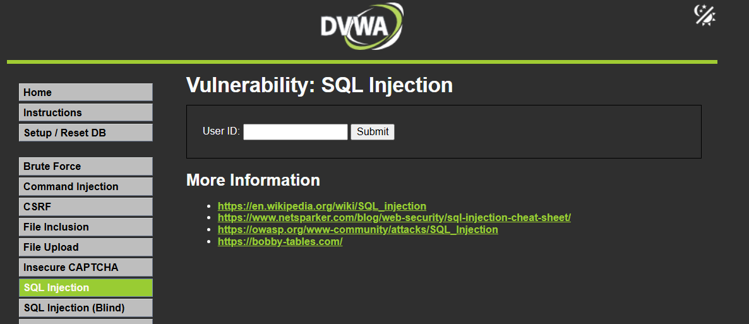

Classic SQL Injection
Payload: ?id=1' OR '1'='1
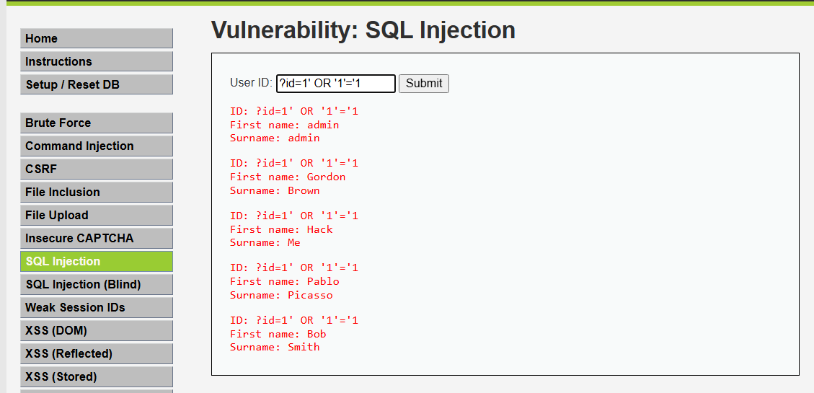

UNION-Based SQL Injection:
Enter: ?id=1 UNION SELECT user,password FROM users-- -
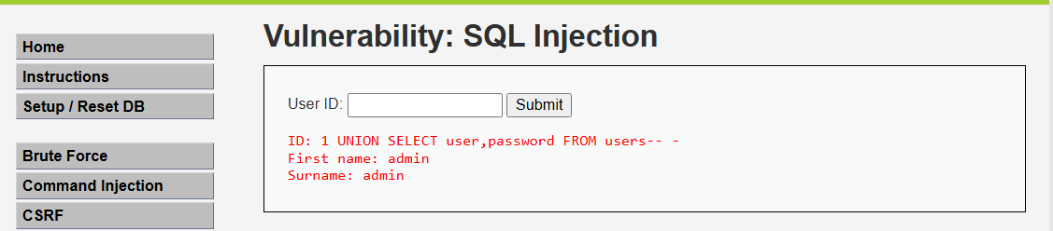

Database Version
Payload: 1' UNION SELECT 1, @@version#
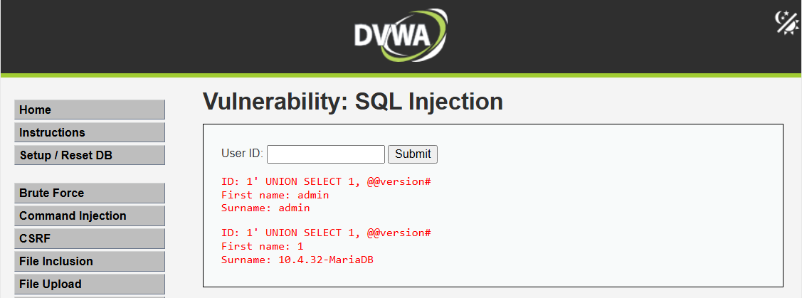

Here we can see that database version is 10.4.28-MariaDB

Command explanation:
- 1' → breaks original query
- UNION SELECT → combines attacker query
- version() → fetches DB version
- -- → comments rest of query

Result : Successfully retrieved database version using SQL Injection

Experiment 2:
SQL injection attack, querying the database type and version on MySQL and Microsoft.

Detect Database Type(MySQL):
Command: 1' UNION SELECT null, @@version-- -
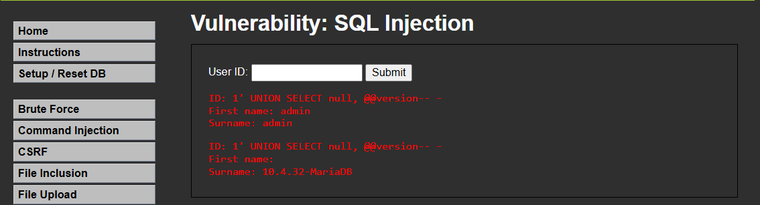

There is only MariaDB database.

Experiment 3:
Blind SQL injection with conditional responses.

Go to this link in your localhost:
http://localhost/dvwa/vulnerabilities/sqli_blind/

Enter: 1 AND 1=1
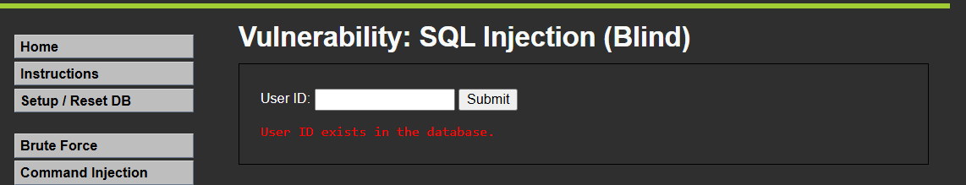
Logic
1=1 → TRUE → valid user → response shown
1=2 → FALSE → no result → different response

Experiment 4:
Stored XSS into HTML context with nothing encoded.

Go to this link in your localhost:
http://localhost/dvwa/vulnerabilities/xss_s/

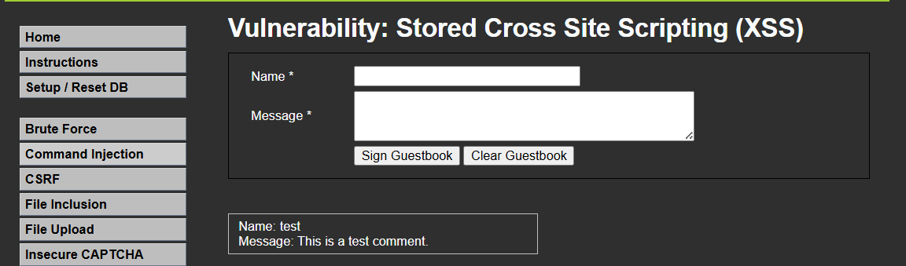

Enter this:
Name: Neel
Message: <script>alert(‘XSS Vulnerability Detected')</script>

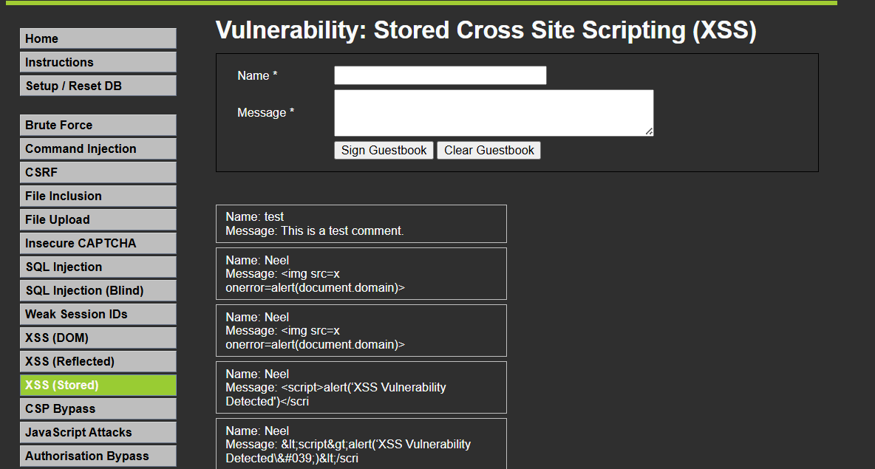

Experiment 5:
DOM XSS in document.write sink using source location.search

Go to this link in your localhost:
http://localhost/dvwa/vulnerabilities/xss_d/

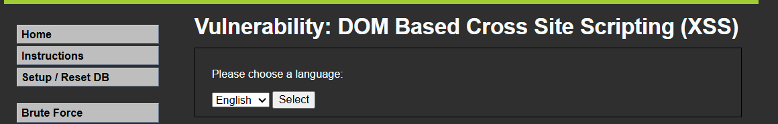

What is DOM XSS ?

DVWA uses something like : document.write(location.search);

Means :
- Whatever is the URL → directly printed
- No filtering → vulnerable

Inject Payload via URL
Modify URL like below:
http://localhost/dvwa/vulnerabilities/xss_d/?default=%3Cscript%3Ealert('XSS')%3C/script%3E

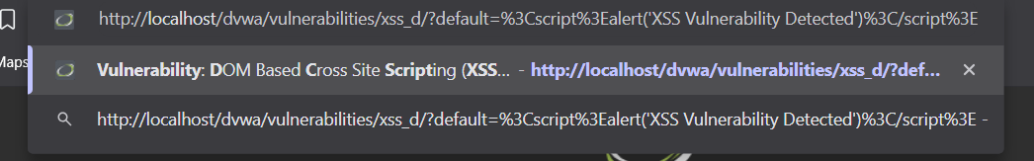

As soon as page loads, alert popup appears → DOM XSS Vulnerability Detected
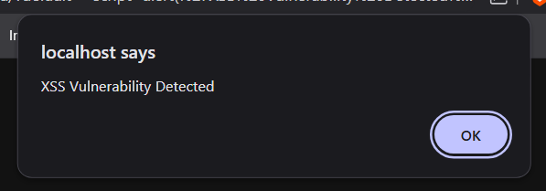

Why this works:
- location.search retrieves user-controlled data from the URL
- document.write injects that data directly into the page’s HTML
- Since there is no input validation or sanitization, the injected script executes

This results in a DOM-based Cross-Site Scripting, where the attack is carried out entirely on the client side.

Experiment 6:
Exploiting cross-site scripting to steal cookies.

Go to this link in your localhost:
http://localhost/dvwa/vulnerabilities/xss_s/



Enter this:
Name: Neel
Message: <img src=x onerror=alert(document.cookie)>

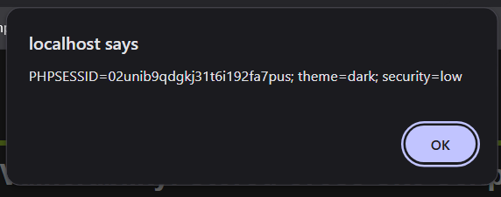

What’s happening:
- document.cookie retrieves the user’s session-related data
- The injected script can transmit this data to an attacker-controlled server
- An attacker can then:
  - Hijack the active session
  - Impersonate the victim without needing credentials

This demonstrates how a Stored XSS can be used to extract cookies and compromise user sessions.

Experiment 7:
CSRF where token validation depends on request method.

Go to this link in your localhost:
http://localhost/dvwa/vulnerabilities/csrf/

We will see the form with New Passwords and Confirm Password
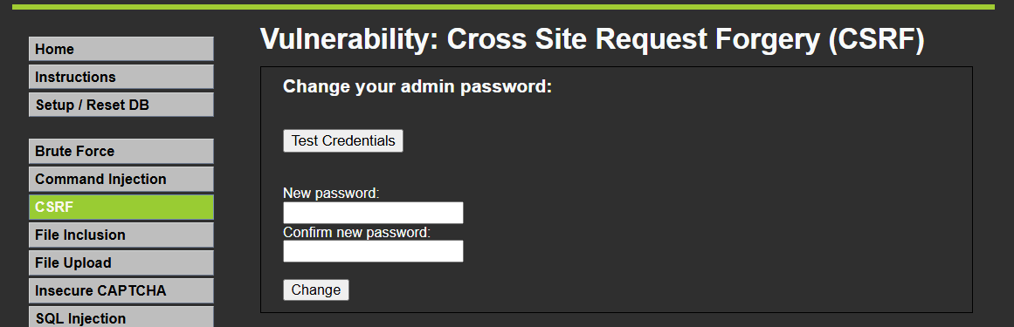

Enter:
Password: 12345
Confirm: 12345

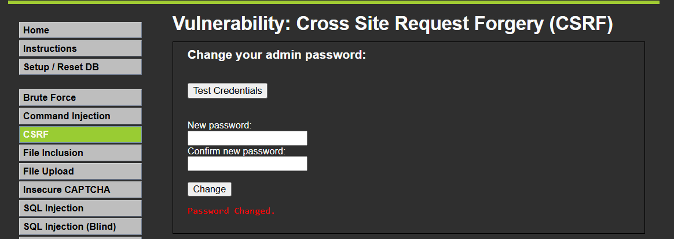

Look at the URL:
http://localhost/dvwa/vulnerabilities/csrf/?password_new=12345&password_conf=12345&Change=Change#

Where is the Vulnerability?
- No proper CSRF token validation
- Uses GET request
- Server trust request blindly

Now let’s attack using a HTML
Create file: csrf_token.html
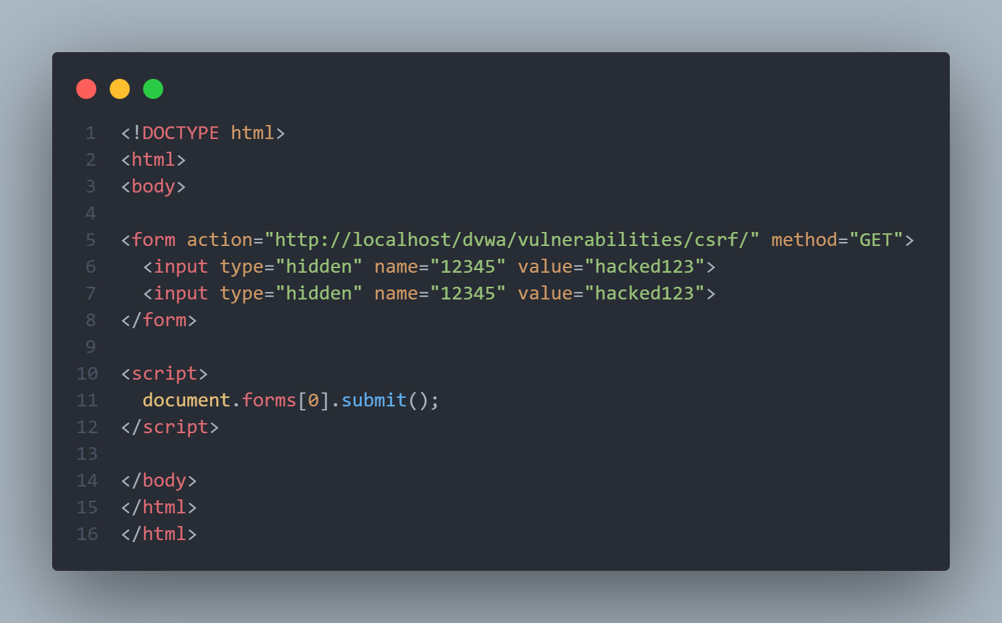

Open this file in the browser, password will change automatically

Result :
Password changed without user consent, we successfully performed CSRF attack

Experiment 8:
Clickjacking with form input data prefilled from a URL parameter.

What is Clickjacking ?
User clicks something they don’t see clearly

Go to this link in your localhost:
http://localhost/dvwa/vulnerabilities/csrf/

It accepts parameters :
?password_new=hack&password_conf=hack&Change=Change

Now let’s attack using a HTML
Create file: csrf_clickjacking.html
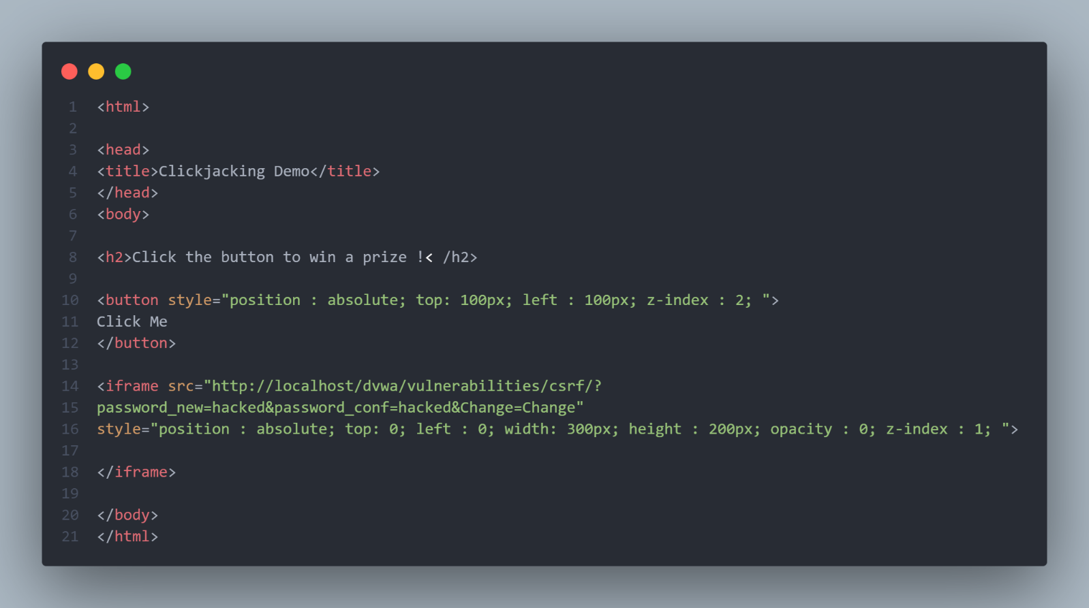

Open the File in browser
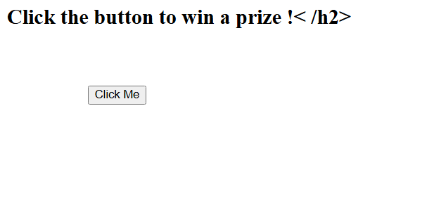

But here actually it’s clicking hidden DVWA from inside iframe

Result :
Password gets changed to hacked and user does not realise that

